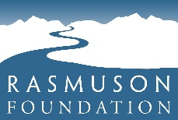
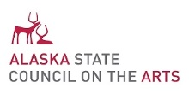

Arts Educator Fellowship
  - A program of the Alaska State Council on the Arts | Guidelines

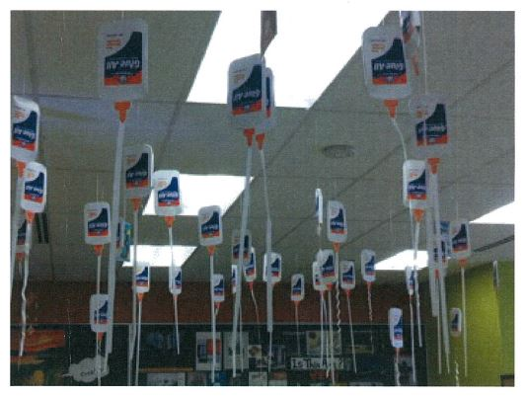
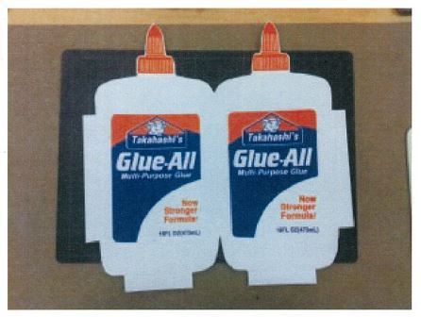
Fellowship Purpose
“I had never thought about using screen printing for other art forms rather than two-dimensional art.”
2014 Arts Educator Fellow—Shoko Takahashi took a summer class in screen printing at California College of Art, and created an art installation in her Anchorage art room.
Are you a school drama specialist, who would like to attend a workshop out of state to learn new skills in your art form?
Are you a classroom teacher who teaches the arts and would like to take classes at a local art studio for the summer?
Are you a district cultural specialist, looking for an opportunity to grow your skills in a traditional art form and create a body of work?
Are you a science teacher, who also teaches music, looking to take lessons with a musician in a musical form that is new to you?
Rasmuson Foundation initiated the Arts Educator Fellowships to encourage the reconnection of artists who are teachers to the practice of their art; Arts Educator Fellowship are a program of the Alaska State Council on the Arts (ASCA), supported by funding from Rasmuson Foundation. The Arts Educator Fellowship program provides grants to certified, permanently-assigned, full and part-time K-12 teachers to immerse themselves in their own creative work, interact with professional artists, and stay current with new practices. The Arts Educator Fellowship is meant to create opportunities for Alaska teachers to fill their own artistic wells.

Fellowship Overview
- Eligible applicants may apply for up to $3,000.00 in support of Arts Educator Fellowship (AEF) activities, based on actual expenses.

- Generally, AEF activities should focus on increasing/advancing artistic skills and professional opportunities, rather than explicit focus on teaching skills and opportunities. Activities may include, but are not limited to: study at arts courses; attendance at advanced art-making workshops, festivals or institutes; residencies at artists colonies; formal mentor relationships with recognized professional artists or other artistic entities or; purchase of materials or equipment to produce a new body of work.

- Once AEF awardees have completed their fellowship activities, they have the opportunity to propose a project engaging their classrooms and/or communities that relates to the fellowship activity. An awardee may receive an additional $500.00 in support during the school year immediately following the fellowship activity, for such a project. Follow-up projects may include exhibits, performances, lectures, demonstrations, workshops, supply and materials purchase, and other activities.

Arts Educator Fellowship
  - A program of the Alaska State Council on the Arts | Guidelines

Eligibile Applicants
- K-12 educators whose responsibilities include the teaching of visual, performing and/or media arts, inclusive of contemporary and traditional art forms.
- Must be a permanently assigned, full or part-time K-12 teacher in Alaska.
- Must plan to continue as an educator in Alaska.
- Previous Fellows may be eligible to reapply, after a period of three years.
- Must be a legal resident of Alaska.

Applications Evaluation Criteria
- Demonstrated quality of practice as teacher and artist
- Quality and relevance of the proposed activity to the applicant’s artistic practice and advancement
- Quality and realistic expectations of plan
- Anticipated impact of post-award on future teaching

Reporting and Other Considerations
- Activities should be completed no later than August 31st of the application year. Applicants are expected to file a final report on the impact of their experiences, no later than 30 days after the completion of the activity. This report may be in a variety of formats, including a written narrative, a video diary, or a blog on the experience.

- ASCA will invite Fellows to share their report in ASCA communications, including the monthly newsletter, to inspire other teachers of the arts. Arts Educator Fellows are invited to join a Facebook group as a space for Fellows to connect with each other, and to post about their own experiences teaching in the arts.

- The IRS provides that some grants be excluded from taxation under certain circumstances. ASCA encourages you to contact your local IRS office for detailed information upon receipt of your grant.

- ASCA staff can provide feedback on draft AEF applications if submitted for review at least 10 days prior to the application deadline.

Application Deadline
Arts Educator Fellowship applications must be submitted to the Alaska State Council on the Arts by March 15th of a given fiscal year. The Alaska State Council on the Arts’ fiscal year is July 1 – June 30. If you have questions about when you should apply for the fellowship, please contact the program administrator.

Arts Educator Fellowship
  - A program of the Alaska State Council on the Arts | Guidelines

How to Apply
A completed application consists of the Application Form, a Fellowship Narrative, the Fellowship Budget Form, the Checklist with Certification, and attachments. Submit a completed application by the appropriate deadline by mail, in person, or via email to:
Alaska State Council on the Arts
Attn: AIE Program, Arts Educator Fellowships
161 Klevin Street, Suite 102
Anchorage, AK 99508
-or-
Via email to laura.forbes@alaska.gov.
We are unable to accept faxed applications. If you are sending your application via email, please include “Arts Educator Fellowship Application” and your name in the email subject line. Applications may be either typed or hand-filled; please be sure the application text and any digital file of the application (scanned pdf materials are preferred) are legible, and compatible with a Windows-based PC. If sending a digital file, it is best to attach a single file to an email, but multiple attachments will be accepted. If sending multiple email attachments, please label them in such a way that the total number of attachments is apparent. For example: “Arts Educator Fellowship Application for XXXX: Attachment 1 of 4”
Email laura.forbes@alaska.gov or call (907) 269-6682, with questions, concerns or for technical assistance; in particular, please contact us right away if the application materials and requested submission process present a barrier to access for an eligible applicant.
The Application Form, a Fellowship Narrative, the Fellowship Budget Form, the Checklist with Certification, and attachments guidance are included in this document, on following pages.

Arts Educator Fellowship
  - A program of the Alaska State Council on the Arts | Application Form, Narrative

Applicant Information
Name:
Mailing Address:
City, State, Zip Code:
Contact Phone Number(s):
Contact Email Address(es):
Your Website Address (if applicable):
Arts Discipline of Focus for Fellowship Activities:
For how many years have you been teaching in Alaska schools, and overall?:
What art forms are currently included in your teaching assignment?:

Applicant School Information
Name of School at which you currently teach:
Public School District (if applicable):
School Mailing Address:
City, State, Zip Code:
School Principal/Leader:
School Principal/Leader Contact Phone Number:
School Principal/Leader Contact Email Address:

Fellowship Activity Information
Proposed Dates of Fellowship Activity:
Activity Summary Description (no more than three sentences, please be specific):

In what category of activity does your proposed activity fall? (Creating New Work, Training or Study & Creating New Work, Training or Study, Other—please describe):

How did you hear about the Rasmuson Foundation Arts Educator Fellowship Program?:

Total Cost of Proposed Fellowship Activity: $ | Fellowship Request: $
May we add you to our e-news list? Please respond, yes or no:

Fellowship Application Attachments
- A Fellowship Narrative of two pages in length
- Resume or Curriculum Vitae (do not include work samples)
- Letter of recommendation from principal or chief school administrator
- If applicable, include support materials that demonstrate the quality of the activity you propose, for example: include a bio for the artist with whom you propose to study

Arts Educator Fellowship
  - A program of the Alaska State Council on the Arts | Budget Form

Fellowship Sources of Income
List funding anticipated for the proposed fellowship activities, both cash-on-hand and contributed. Identify the sources and amounts, and place an asterisk (*) by funding already secured. List separate and in-kind sources (donated services, goods and materials needed for the project for which you would otherwise pay) “Applicant Cash” refers to the Fellowship Applicant’s personal funds, which may be used to support the fellowship activities.
Please note: There is no required financial match to the Arts Educator Request, nor is there any expectation that a fellowship applicant has multiple sources of income in this budget. Do not include potential follow-up activities in this budget, but rather only the funding in support of the proposed fellowship activity.
Category | Cash Amount $ | In-kind Amount $*
Applicant Cash
Other Contributed Support
Other (please list)
Other (please list)
Subtotal
Arts Educator Request (up to $3000.00)
Total Fellowship Income

Fellowship Expenses
In the table below, please detail all expenses associated with your proposed fellowship activity. List all expenses related to this project by category (travel, tuition, lodging, supplies, child care, etc.). Include in-kind expenses (matching that listed on the income side, above), such as donated lodging, supplies, services, etc.
Category | Cash Amount $ | In-kind Amount $*
Transportation
Lodging
Per Diem/Accommodations
Supplies and Materials
Training or Program Fees
Other (please list)
Other (please list)
Other (please list)
Other (please list)
Total Project Expense

Budget Narrative
Briefly below, please note anything that you believe may be helpful to application reviewers in understanding your proposed budget.

Arts Educator Fellowship
  - A program of the Alaska State Council on the Arts | Narrative

Fellowship Narrative Questions
Your narrative should respond to the following questions—about two pages in length—with at least an 11-point font type. It is helpful to format your responses in alignment with the numbering, below; it is not necessary to restate the questions within the body of the narrative, unless that is helpful to you.
  - Describe your current involvement in arts activities and your arts teaching experiences.
  - What do you propose to do with Arts Educator Fellowship funds? Describe the activity including when and where it will take place. If applicable to your project, provide the name and description of the program you plan to attend. Include short bios and names of lead artists, mentors or organizations you will work with, as attachments.
  - What are your artistic development goals and how will this experience/activity help you reach them? What will the experience will bring to you as an artist?
  - How do you think this activity will help your development as an educator?
  - What do you propose as a format for your final report narrative?
  - Following completion of an Arts Educator Fellowship, awardees have the opportunity to propose a project engaging their classrooms and/or communities that relates to the fellowship activity. An awardee may receive an additional $500.00 in support during the school year immediately following the fellowship activity, for such a project. Very briefly, what might you propose to do, in follow-up?

Application Submission Checklist
Have you completed/included each of the following for your application package?
Complete and include the Application Form |  | Include a Letter of Recommendation from principal or school leader
Complete and include a Budget Form |  | Include Program Support Materials for proposed activities, if applicable
Complete and include a Narrative |  | Make and keep a copy of your application (for your reference)
Compete and include the Checklist and Signed Certification |  | Digitally send, deliver, or postmark your completed application no later than 3/15
Include a Resume and/or Curriculum Vitae

Certification
By signing this grant application, I certify that the information contained in this application, including attachments, is true and correct to the best of my knowledge.
Certification
Signature of Applicant:
Date of Signature:

